Just Coders



17 November 2021 Mr. Ephraim

PROJECT PLANNING DOCUMENT

**Inside Cover Page**

* **Number of the team**
* DISD313 Group 4, with 3 members
* **Name of the team**
* Just Coders
* **Name and student number of team leader**
* Vusimuzi Mphela 17608576
* **Names and student numbers of team members**
* Given Mnguni 18011644
* Ntandoyenkosi Ndaba 16011865
* **Name and logo of the system**
* The Ben Luc System



Table of Contents

1. Introduction3
2. Team members4
3. Milestones and Deliverables5
4. Work breakdown structure6
5. Project Schedule7
6. Gantt chart and interpretation8
7. PERT chart and interpretation9
8. Risk management 10
9. Technical Feasibility Issues11
10. **Economic Feasibility Issues12**
11. **Appendix A13**

# Introduction

The just coders group have identified a website and an android application as a suitable system to provide the organization with a broader presence in the market, the system is developed to increase sales of the ben Luc designer clothing items and the regular customer or potential customers are unable to make online purchases of their favourite ben Luc clothing items because the organization has no website.

The Development of the ben Luc system is expected to give the business an increase in the number of customers who interact with the services the business offers with an estimate of 69% percent, the ben Luc system is developed to permit online transactions which will increase the sales percent of the Ben Luc clothing items by an estimated 60% percent.

# Team Members



Team Leader

Full Name: Vusimuzi Mphela

Student No: 17608576

**Role**: Project Manager, the project manager is responsible for managing the project. The project manager oversees everything that the team is doing, and he is also responsible for assigning the team members tasks to make sure that the project milestones are completed.



Team Member

Full Name: Ntandoyenkosi Ndaba

Student No: 16011865

**Role**: Software Developer, the software developer is the one who is responsible for designing the graphical user interface, he is responsible for the development of the software that will bring a solution to the project’s identified problem.

Team Member

Full Name: Given Mnguni

Student No: 18011644

**Role**: Business Analyst, the business analyst is responsible for analysing the operations of the organization, to develop a solution to its problems. The business analyst is the one who is responsible for designing entity relationship diagrams, use cases and defining the risk analysis reports.

# Milestones And Deliverables

* **Initiating**
* Baseline project plan prepared, and project charter signed/approved
* **Requirements**
* User review and accept documents
* **Design**
* Backend design
* Frontend design
* Review and approved design model
* **Implementation**
* Setup database
* Approve application
* **Testing**
* Unit test
* Integrate test
* User acceptance testing
* **Deployment**
* Develop User manual
* **Project Closure**
* Document ben Luc system

# Work breakdown Structure

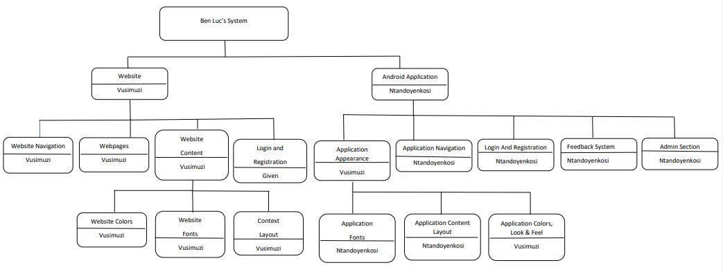

# Project Schedule

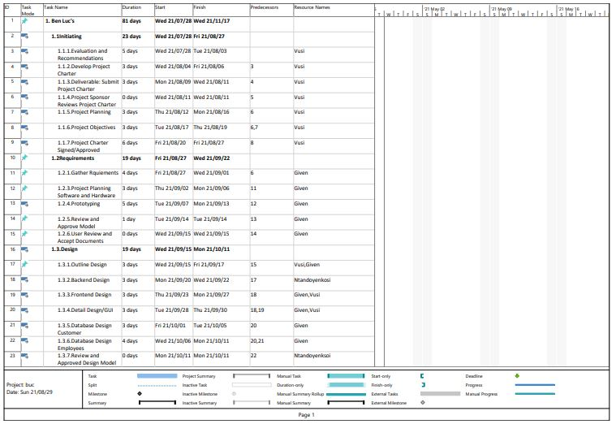

# Gant Chart

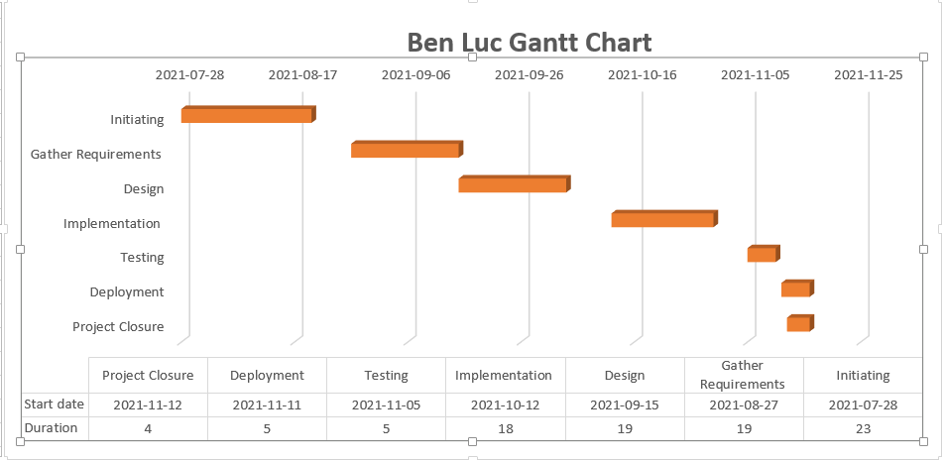

# PERT chart

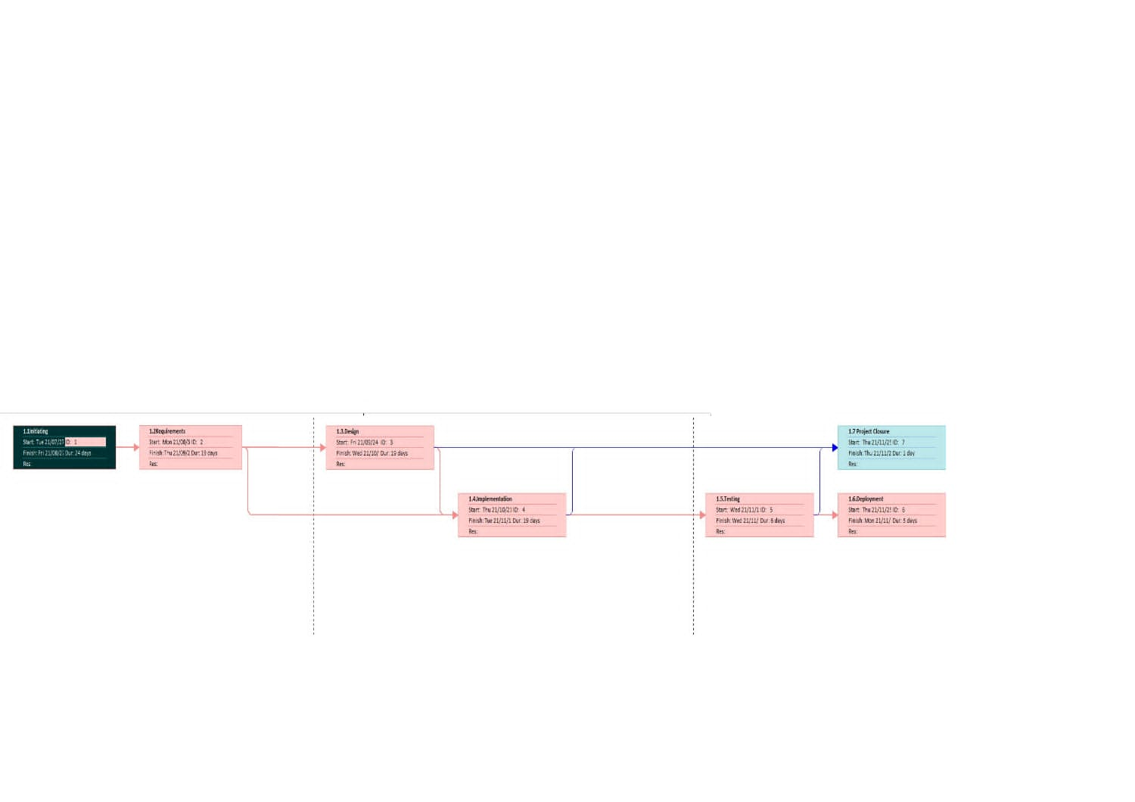

# Risk Management

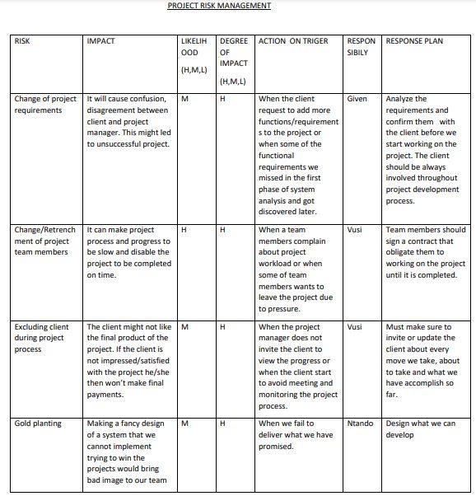

# Technical Feasibilty Issues

Hardware resources needed to develop the Ben Luc System

* 10GB of device storage
* Minimum 2.0hz dual core processor
* Minimum 4GB of memory (RAM)
* Minimum 500MB Video dedicated memory (graphic card)
* A computer device
* All the identified hardware resources needed to develop the ben Luc system are available.

Software resources needed to develop the Ben Luc System

* Android Studio 2020 Arctic fox must be installed on the computer device.
* A computer that has installed a windows operating system.
* Minimum windows 10 Home edition operating system.
* Notepad++ executable program installed on a computer device.
* Wamp Server/Xampp server.
* Web browser.
* All the identified software resources needed to develop the Ben Luc system are available.

# Economic Feasibility Issues

|  |  |  |  |  |
| --- | --- | --- | --- | --- |
| Activity/ Task | Team member responsible | Time allocated for task in hours | Task tariff in rands/ hour | Total budget for effort (time* tariff) |
| Website navigation | Vusimuzi | 12 hours | R 200.00 | R 2400.00 |
| Application navigation | Ntandoyenkosi | 12 hours | R 180.00 | R 2160.00 |
| Login and Registration | Given | 10 hours | R 210.00 | R 2100.00 |
| Total Budget for project |  |  |  | R **5300.00** |

# Appendix A

The Ben Luc system which made up of the website and android application has been developed to connect, store values, and communicate with the same database. The Ben Luc system is designed using a 3-tier model, the Ben Luc system requires internet connectivity to allow customers to effectively interact with the services the website and android application have to offer.